Project Design Phase-II
Technology Stack (Architecture & Stack)
Date | 03 October 2026
Developer / Student | Vinay Krishna A K
Project Name | Automated Network Request Management in ServiceNow

- Technical Architecture

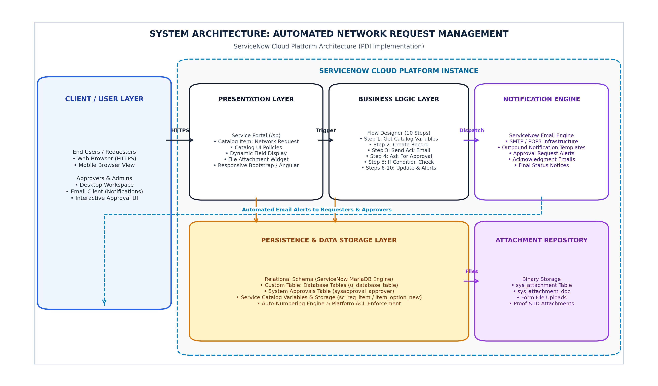

Architecture Overview: The solution is implemented on the ServiceNow Cloud Platform utilizing a multi-tier architectural pattern. The client presentation tier leverages the Service Portal (/sp) with dynamic Catalog UI Policies for request intake. The application logic tier executes a 10-step Flow Designer workflow to manage approvals, database persistence, and branching. Data persistence is handled by a custom relational table Database Tables (u_database_table) backed by ServiceNow's cloud database engine, while platform notification services handle automated outbound communications.

Table 1: Technology Stack Components

S.No | Component | Description | Technology / Implementation
1. | User Interface | Self-service intake form on the Service Portal (/sp) with dynamic fields, choice options, and attachment widget. | ServiceNow Service Portal, AngularJS, HTML5, CSS3, Bootstrap
2. | Application Logic 1 (Intake & UI Policies) | Dynamic client-side form controls to show/hide fields, validate mandatory fields, and handle connection types. | ServiceNow Catalog UI Policies & Client Scripts (JavaScript)
3. | Application Logic 2 (Workflow Engine) | 10-step low-code automation workflow handling variable extraction, record creation, approval routing, and branching. | ServiceNow Flow Designer (Trigger: Service Catalog)
4. | Application Logic 3 (Approval Routing) | Automated approval gate routing requests to designated Manager/Admin and updating approval states. | Flow Action: Ask For Approval (sysapproval_approver)
5. | Database (Custom Table) | Dedicated custom relational table storing all request variables, payment options, addresses, and states. | Database Tables (u_database_table) with Auto-Numbering
6. | Cloud Database | Enterprise relational database backend managed natively by the ServiceNow cloud infrastructure. | ServiceNow Managed Relational Cloud DB (MariaDB backend)
7. | File Storage | Secure repository storing documents and proof files uploaded via the portal form. | ServiceNow Attachment Architecture (sys_attachment / sys_attachment_doc)
8. | Notification Engine | Automated outbound notification services generating emails for acknowledgment, approval alerts, and closure. | ServiceNow Email Notification Engine (SMTP / Flow Send Email)
9. | Security & Access Controls | Role-based security controlling read, write, create, and delete permissions on records and forms. | Access Control Lists (ACLs) & User Roles (snc_internal, admin)
10. | Infrastructure (Platform / Cloud) | Multi-tenant enterprise cloud environment hosting the personal developer instance (PDI). | ServiceNow Enterprise Cloud Infrastructure (SaaS / PaaS)

Table 2: Application Characteristics

S.No | Characteristics | Description | Technology / Mechanism
1. | Open-Source & Standard Frameworks | Underlying front-end responsive web frameworks powering the Service Portal and UI components. | AngularJS, Bootstrap 3.x, HTML5, CSS3, JavaScript (ES6)
2. | Security Implementations | Multi-layer defense: HTTPS (TLS 1.3) data encryption in transit, AES-256 at rest, role-based ACLs, and strict input sanitization against XSS/injection. | Platform ACLs, TLS 1.3, AES-256 Encryption, Role-Based Access Control (RBAC)
3. | Scalable Architecture | Multi-instance cloud architecture decoupling client portal rendering, workflow processing, and database persistence to support growing transaction volumes. | ServiceNow Advanced Multi-Instance Architecture & Load Balancers
4. | Availability | Enterprise-grade 24/7 uptime with automated data replication across paired geographic data centers and high-availability clustering. | ServiceNow High-Availability Data Center Pairs & Automatic Failover
5. | Performance | Sub-second response times achieved via native portal caching, asynchronous Flow Designer execution, and indexing on custom table search fields. | In-memory Cache (GlideCache), Asynchronous Flows, DB B-Tree Indexes

